# Try to create a shell file with some commands and execute/run it

# 

Upload files into a remote repository using SFTP from a local machine.

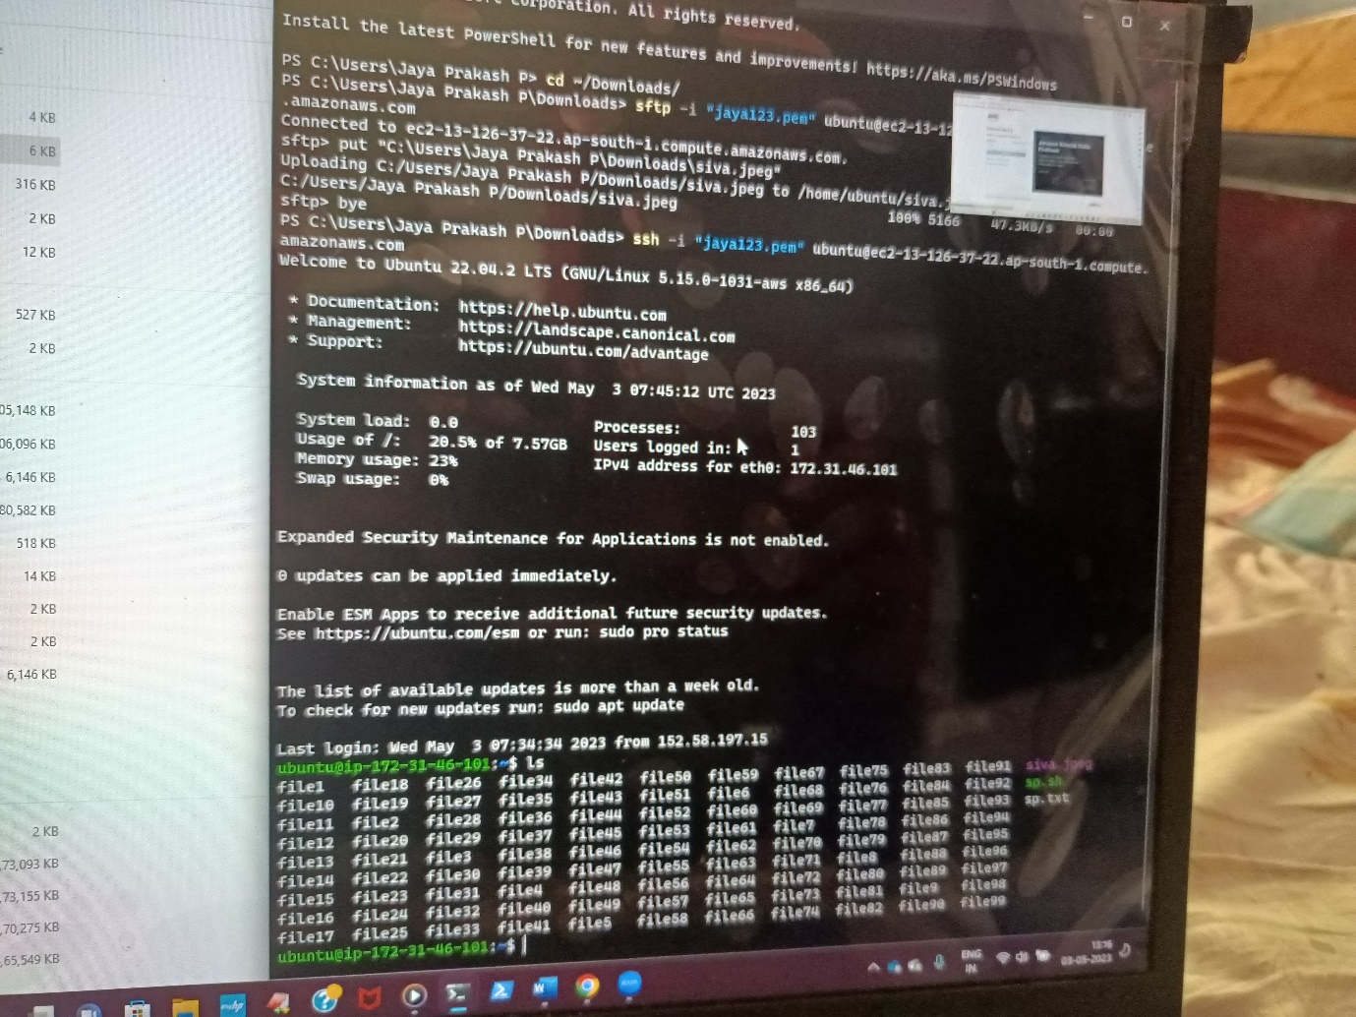

Import key pair/ Ssh keypair concepts on AWS/Azure cloud

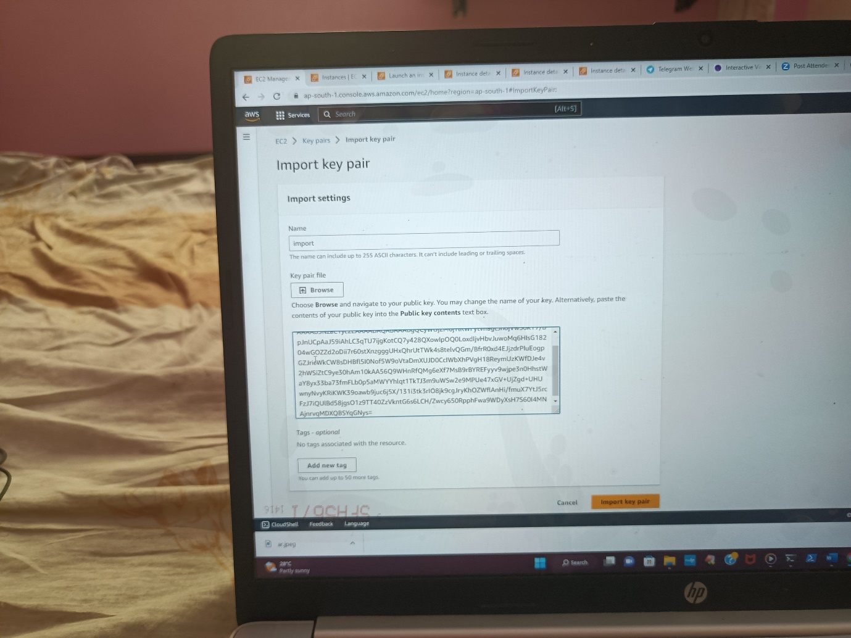

Establish connection between 2 remote machines using ssh

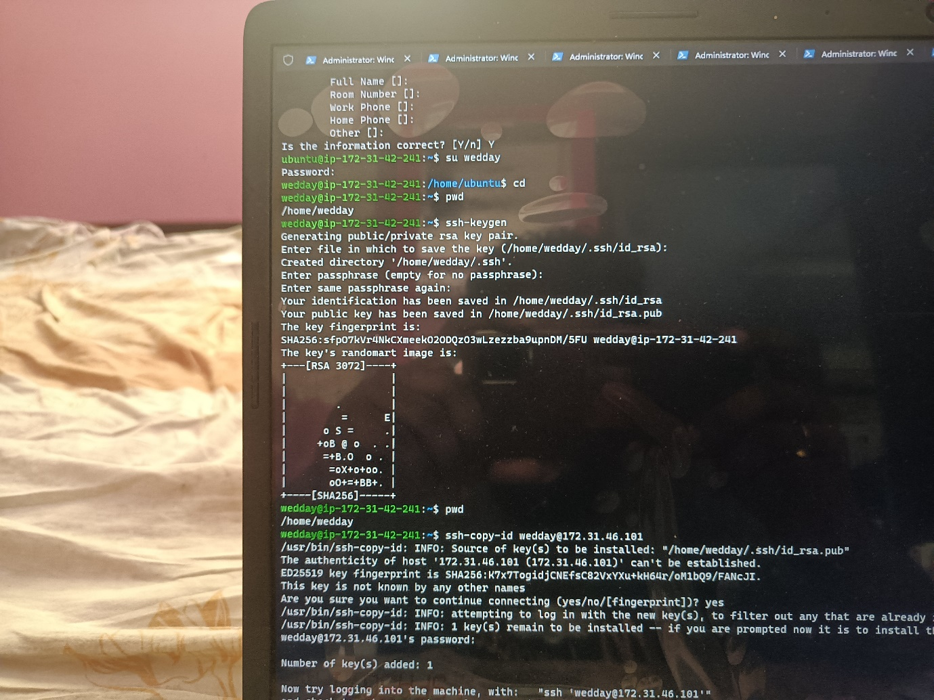

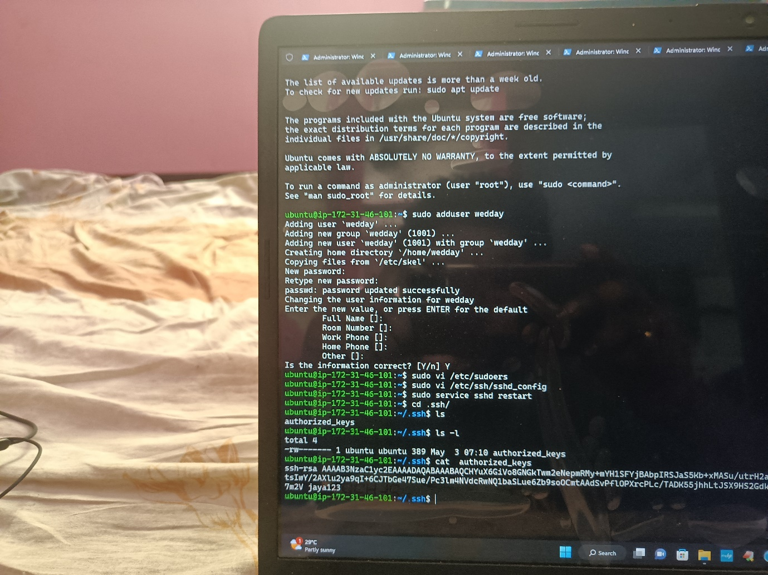

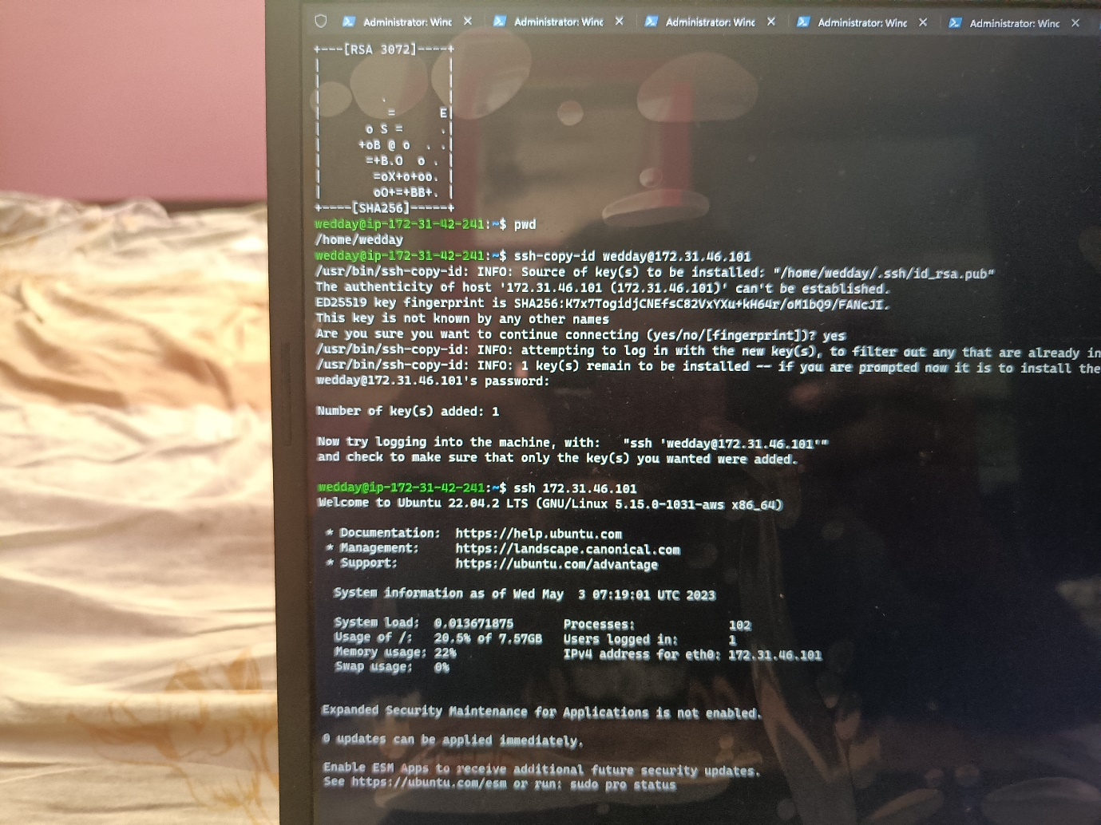

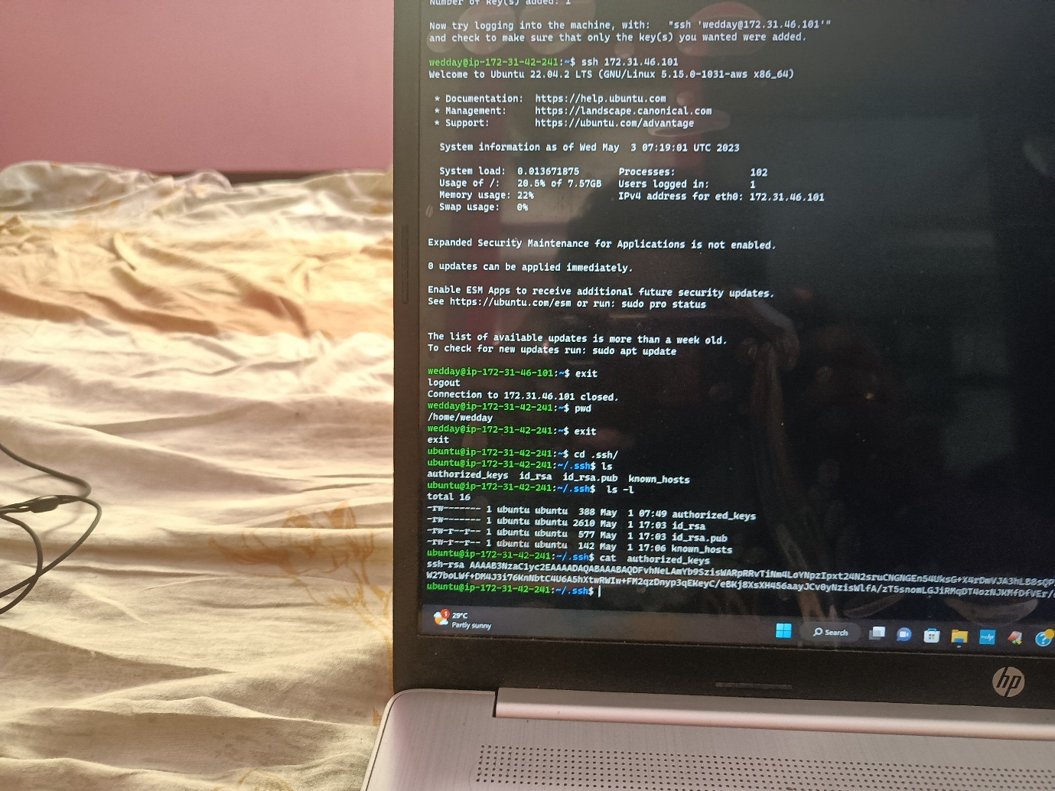

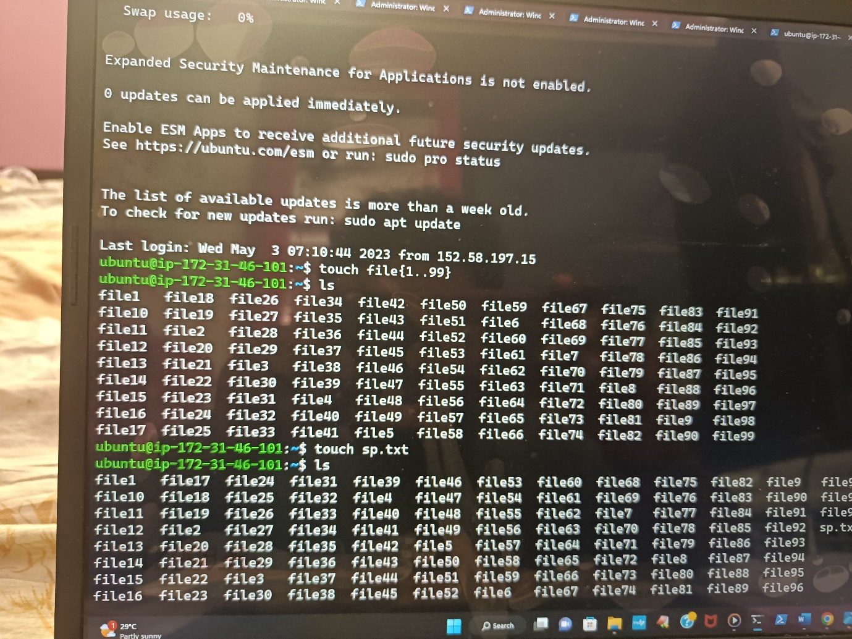

Create 100 files using a single command

Create Directories/Files and hands-on ls,cd,cp,mv,rmdir,rm,touch,mkdir,cat and vi.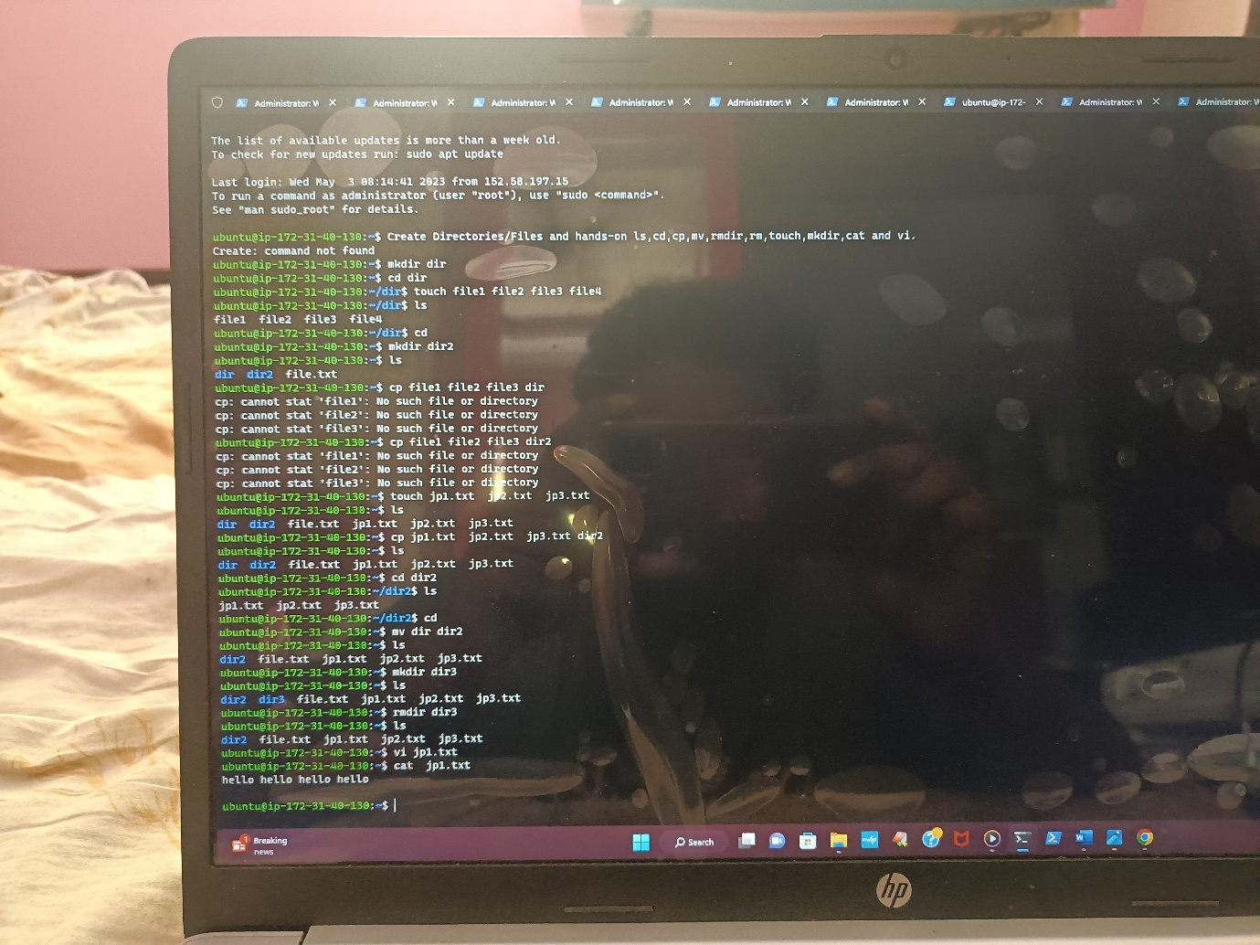

Upload any image inside the web app path and access it through the web

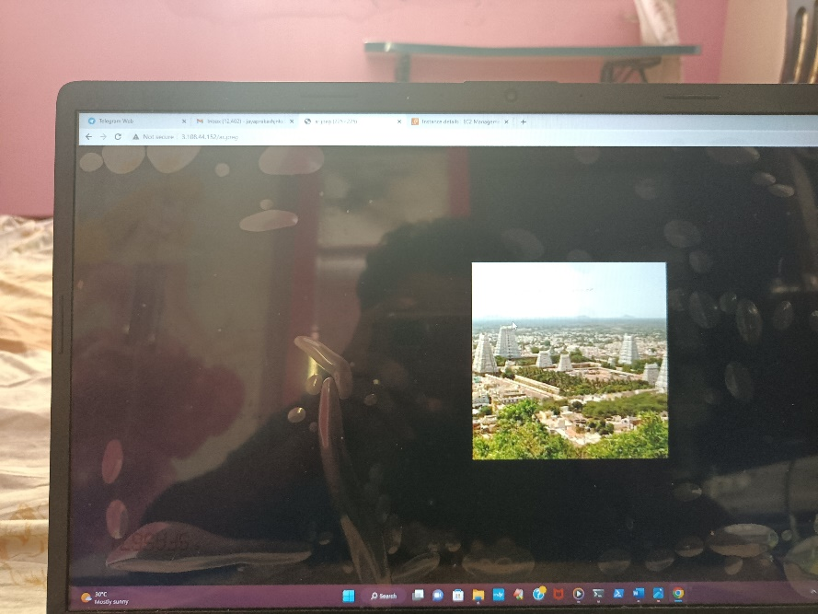

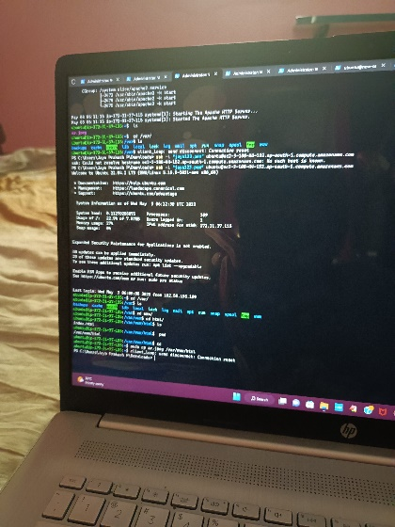

….

Create a VM/EC2 and install apache2/Tomcat web server on ubuntu/CentOS and access it through the internet

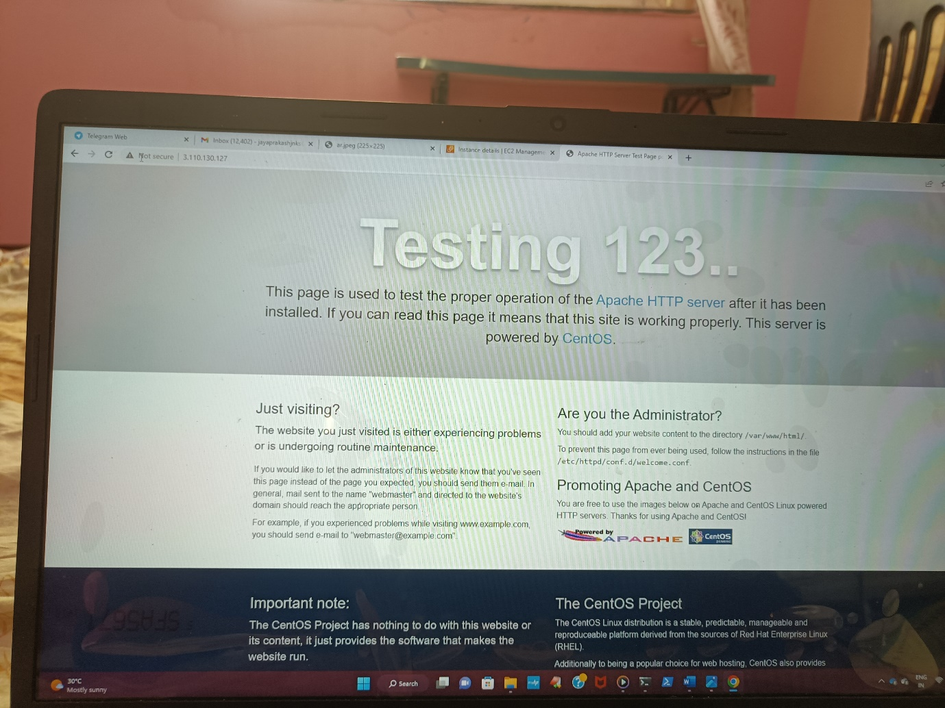

.

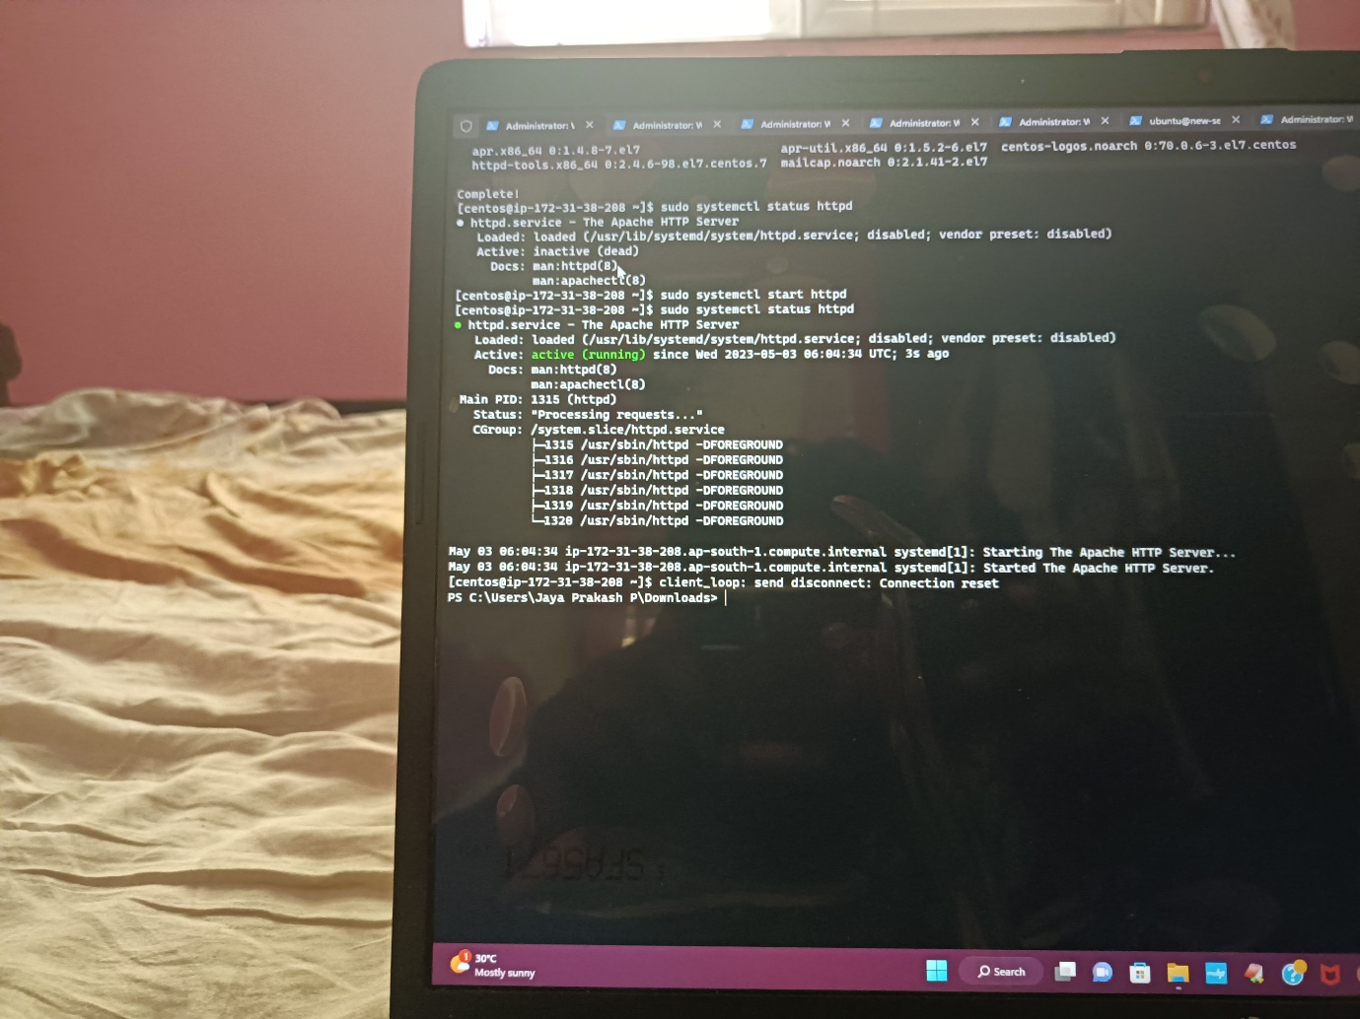

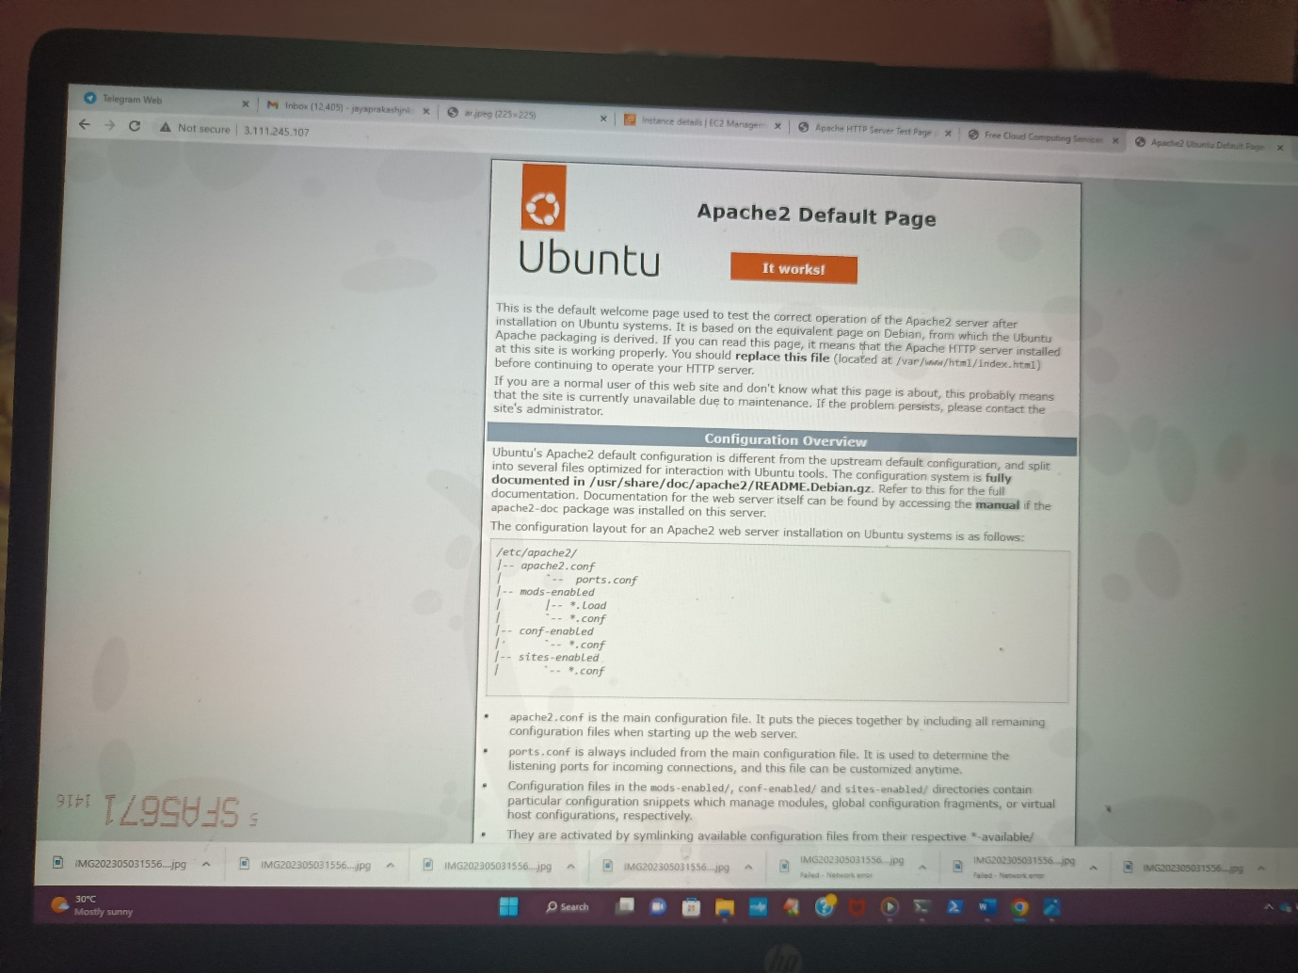

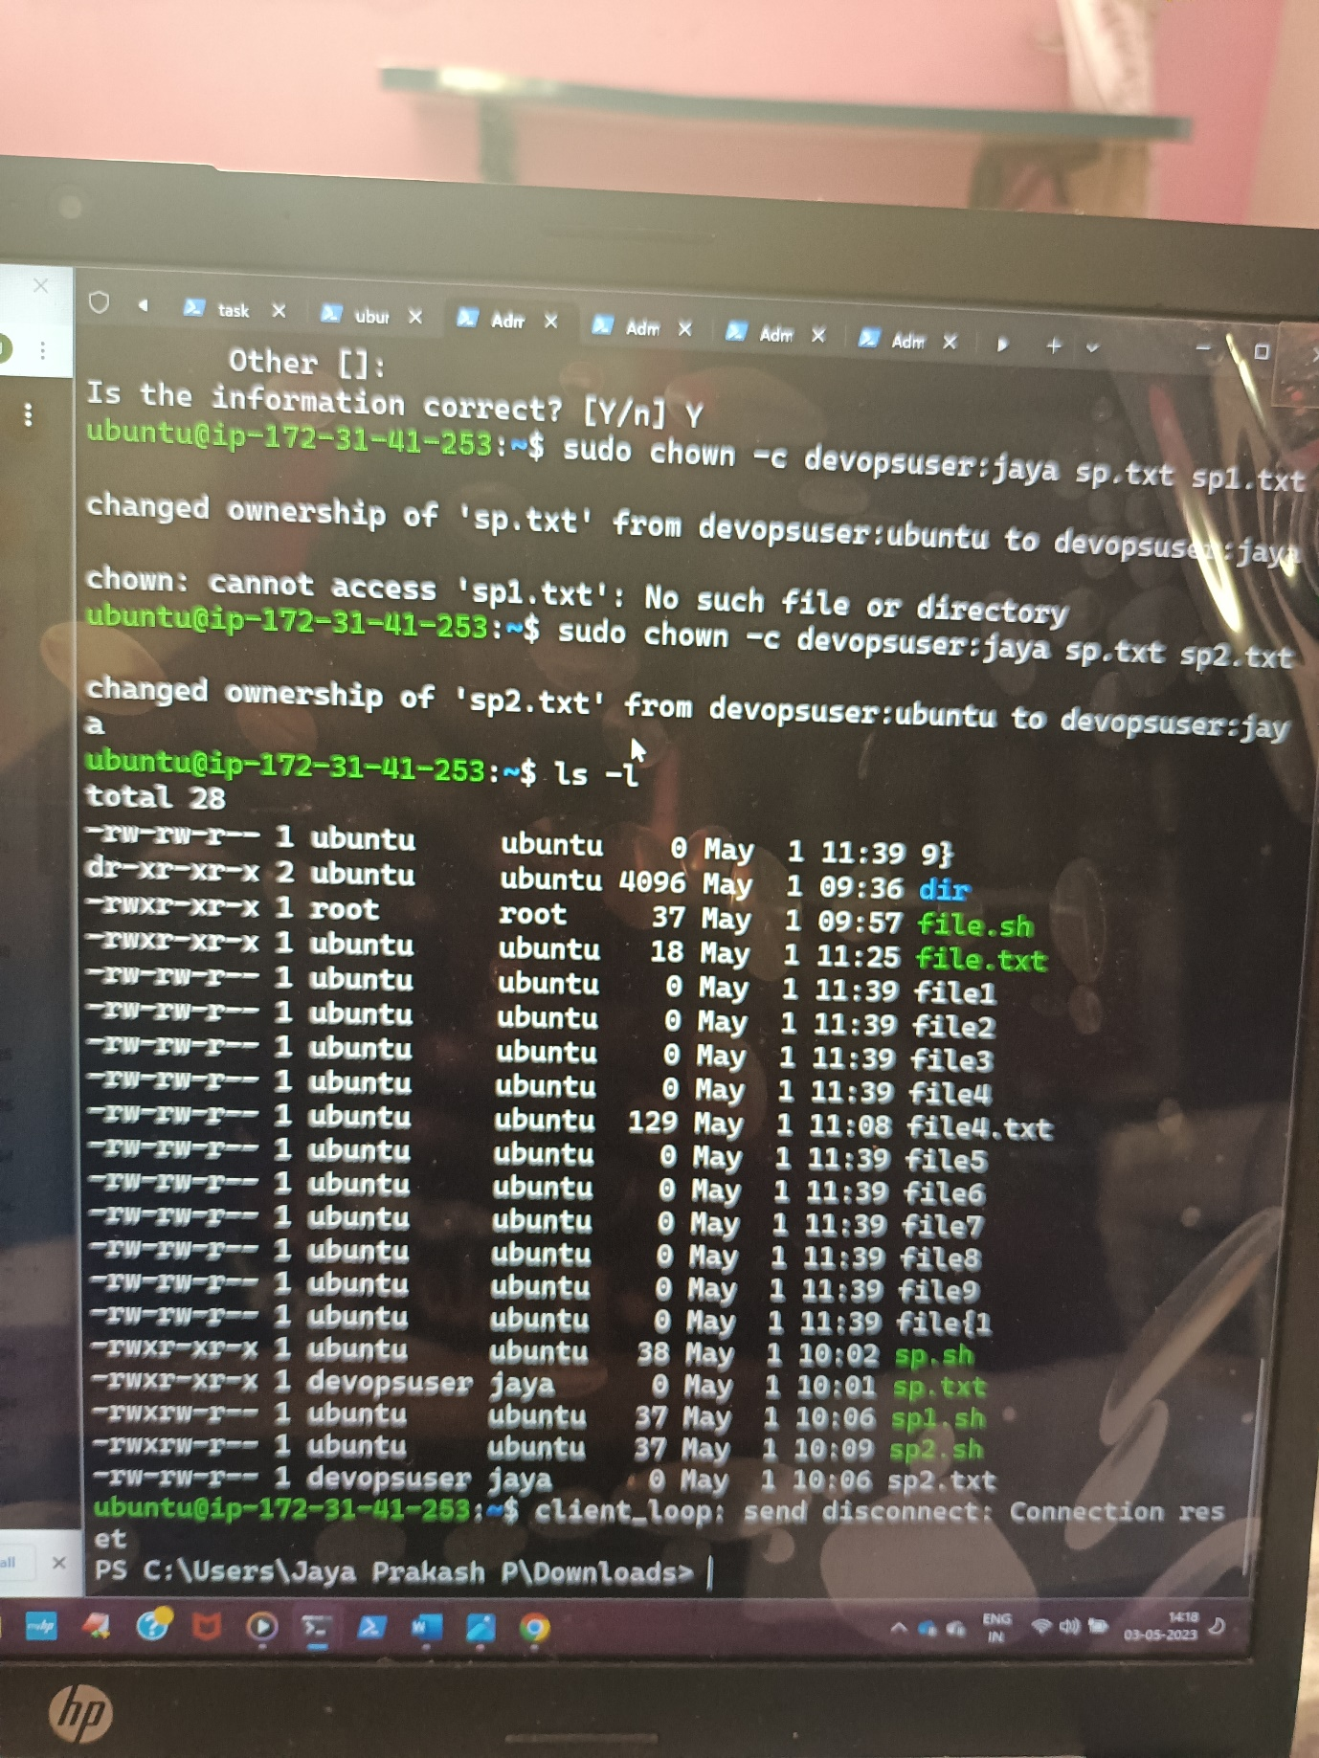hands on change owner premissions

sp.txt sp2.txt



Create users using adduser/useradd/deleteuser/deletegroup/removeuserfrom group and assign passwords and group creation and add the existing user to the group.

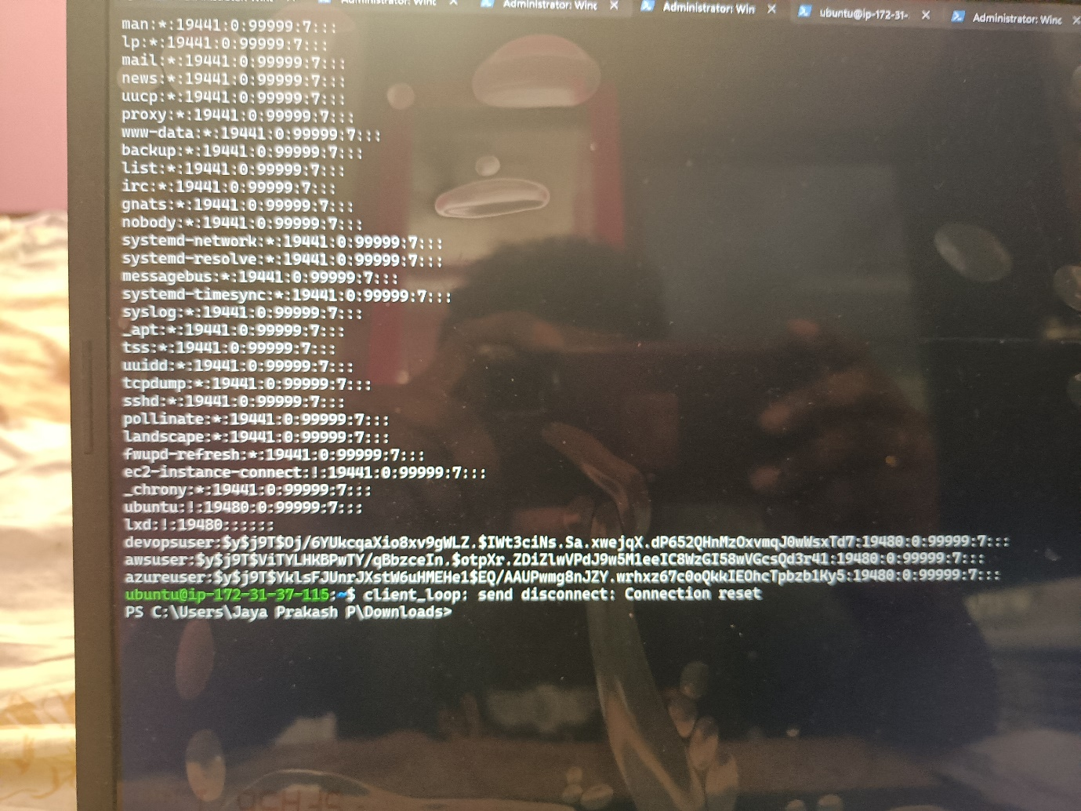

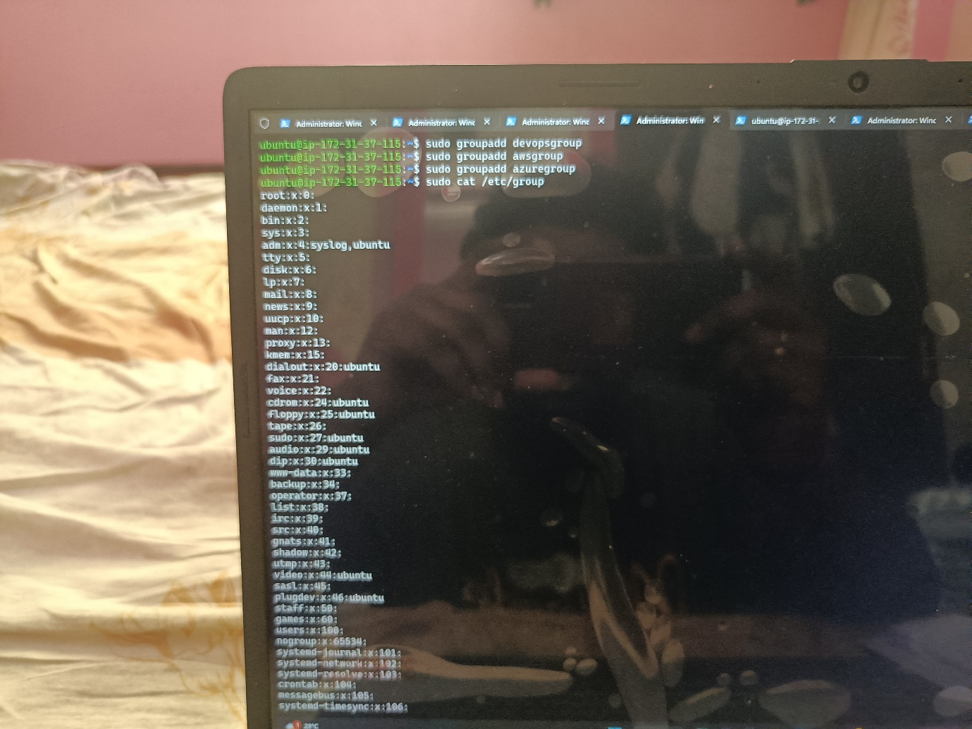



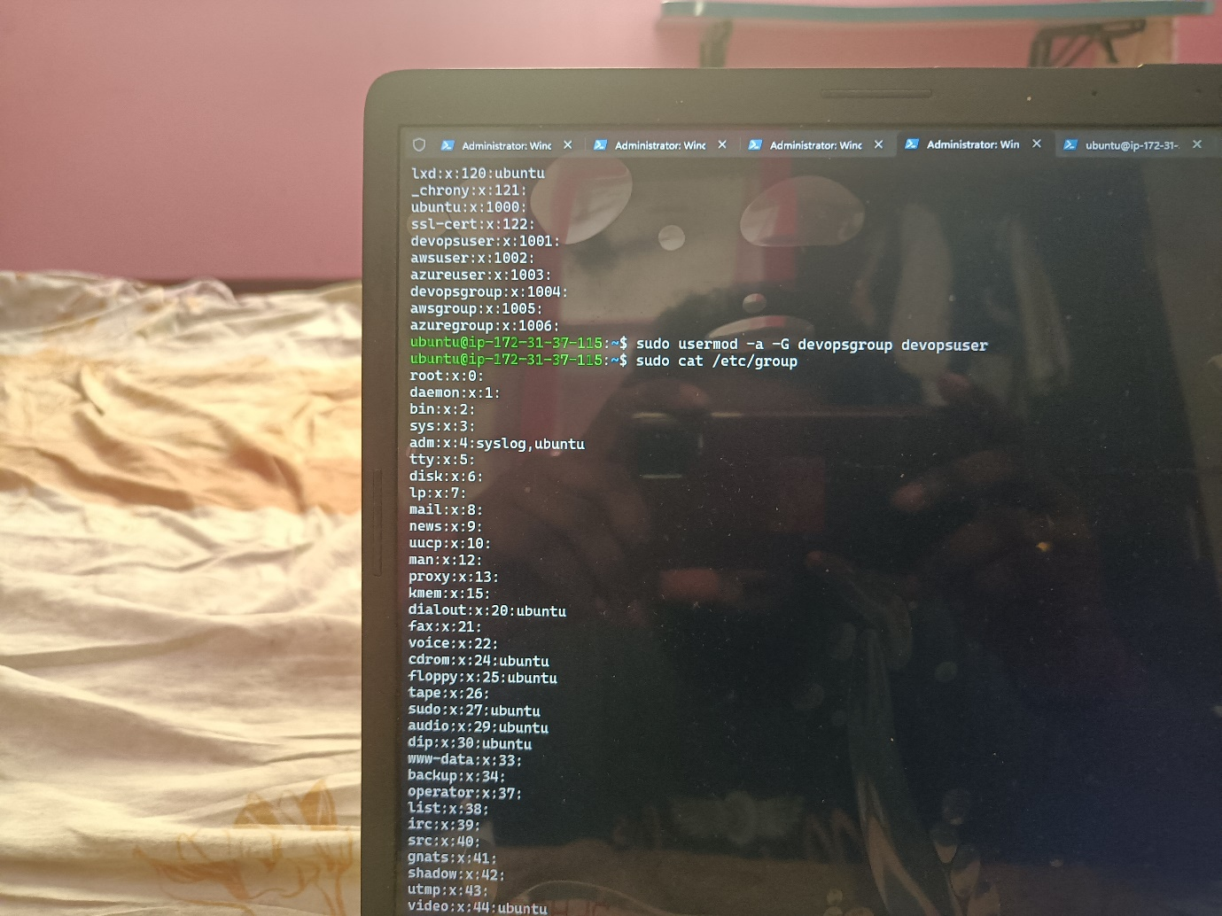



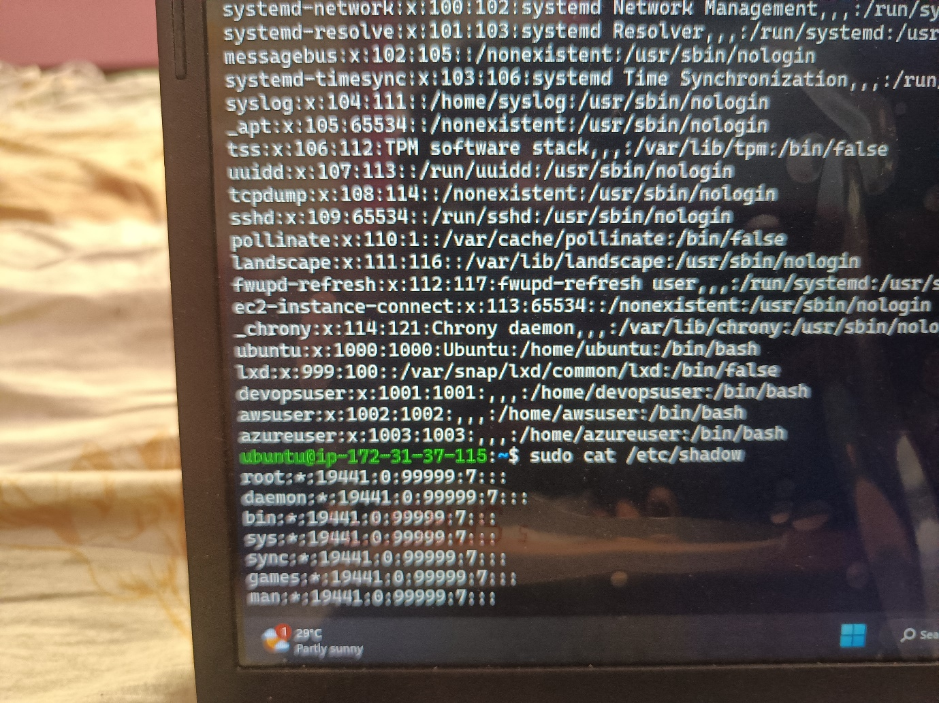Find the location of users,passwords and groups .

